Hunted

*Game Design Document*

Zack Broeg

GIMM

College of Innovation and Design

Boise State University

INTRODUCTION

Hunted is a VR game for the PC that is a person vs person vs environment survival shooter game that pits each player against each other in a deserted town surrounded by a forest.

DESCRIPTION

In Hunted, you as the player are spawned into a forest surrounding a town affected by nuclear fallout. In the distance you can hear mutated beasts and know that you cannot survive without some form of protection that actually works. As you begin to search for ammo, you find that other people are doing the exact same thing as they are looking for the same limited resources. The game turns into a larger person vs person vs environment situation as you want to survive and continue to live another day. The only thing stopping you is everyone else trying to do that exact same thing. Starting out with just an empty gun, you have to move around the area finding gear while also trying to not attract unwanted attention. As you move through the map, tough choices come up on whether or not you should attack someone? How do you handle a beast you have encountered? What routes around the map will you take? Some choices are life or death and some can change your future outcome greatly. You have to rely on quick decisions as well as some type of plan to make sure that you as the hunter, don’t become the hunted. The game ends when you either die, or you are the last on surviving.

KEY FEATURES

* Entirely immersive VR
* Puts decision making as priority
* Gameplay and speed completely controlled by the player
* Situational based gameplay
* Every game will play differently
* Multiplayer support

GENRE

Hunted is classified as a survival shooter game with a strong real-time strategy component encapsulation it. This is due to the choices made on the fly that will further change how the rest of the game is played. It would be further classified as a post-apocalyptic game based on the setting of an abandoned town and forest affected by fallout.

PLATFORM

Hunted will run on PC being an entirely VR compatible game. It would be entirely multiplayer allowing for up to eight players. It may be moved to other platforms later, but for now PC is the best option.

OBJECTIVES

The main objective of Hunted is to be the last person alive to a specific location on the map to win. Secondary objectives that can be done, but aren’t needed to fully win would be killing the beasts as well that go towards a ranking system. As the player, the main objective would be priority because it would result in one potentially winning the game. If you’re playing with friends, that gives an even better experience since you were able to outlast them and would make the secondary objective of how many beasts killed a good bragging right.

MECHANICS

The mechanics for Hunted are pretty simple. There is free movement on all players so the situation is always changing. From there, there will be one attacking mechanic that will be firing a gun. This strips the game down to a very simple and straightforward game and allows for more focus on the game play and strategy. LEAP motion will also be implemented for the inventory and menu system in game.

RULES

All players, beasts, and items are randomly spawned on the map. This allows for a truly unique game every time and prevents the race to where the good items spawn every time like in other games. From there each player starts with a gun and have to find bullets. Players will have to maneuver around the map trying to find gear while also trying to stay alive. There is no healing element to the game to prevent reckless gameplay and makes the player have to plan ahead. It takes two shots to kill someone with a gun so people have the ability to react. The map will slowly shrink as the game progresses to make the new objective of moving closer to a part of the map where the location is found. This mechanic would be continuous, but happen slowly so that it doesn’t force the gameplay to go faster than needed. You are able to use the items however you want so just because you found an excess of bullets, that doesn’t mean you have to fire them. Traps could prove to be just as effective.

CONTROLS

The game will be controlled using the Oculus Rift and Oculus Touch. The controls will have a fairly basic layout that lines up with having a gun in hand. The motion will be locomotion using the joysticks of the touch controllers similar to a regular first person shooter found on a console. LEAP motion will also be used to handle the inventory and menu system in game and give it a nice looking and intuitive feel.

INTERACTIVE ELEMENTS

The player is able to interact with items that are found in the environment like doors and windows. Aside from that a lot of the terrain won’t be interactive.

Physics

The physics of this game works like every other first person shooter when it comes to shooting and collision mechanics. With movement, there will be things like jumping, crouching, and footsteps depending on the material you are walking on. If crouched, you will be silent.

GAME INTELLIGENCE AND BEHAVIOR

The only AI would be the beasts. They would have a sight range and depending on if they are facing you and you are within that range would dictate if they attack. They would also only notice you if you are not hiding or making an effort to be stealthy. So running down the middle of the street may make them more likely to attack compared to moving through the trees crouched and moving slowly. They will have good path finding to be able to chase you down through the trees and buildings without being clunky or unnatural.

MULTIPLAYER

It will be a purely multiplayer game that supports will at least two people.

STORY STYLE

With this game, there is no direct story, but rather an inferred one. I would classify if more as a mix between a horror and fiction story because it is not based off a real event and some of the aspects of the game pull from horror games or ideas. The setting of the story will be in modern times. This is the best style of story for my game since the story itself does not affect the gameplay. A person can play this game without any background knowledge and still get the same enjoyment out of it. Based off of the main objective of the game, the setting, as well as small details found in the environment, the player will be able to infer what could have happened and why they are there. The post-apocalyptic setting will give a decent amount of information as well.

BACKGROUND STORY

The area in which the game takes place is in a nuclear fallout zone and has been for a few decades. As a result, there are some unnatural beasts roaming around the abandoned town and the surrounding forest. As you’re playing the character that you are spawned in as, you may start to pick up small details to give a bit of information about them.

STORYLINE

There is no real story to follow. It is very much an arcade styled game where you may be able to pick up on the background story of what may have happened, but it is not needed. It would be similar to Blizzard’s Overwatch.

CHARACTERS

There will be at least two seemingly normal looking people that could also potentially have some background to be found that are unique to them.

LEVEL DIAGRAM

Town Area

GRAPHIC STYLE

My graphic style is going to be a more cartoonish style as it’s the one I do best at creating. I’d ideally like it to lean more realistic instead of full on cartoon.

WORLD

The world will be a forest surrounding a town, so the player will be able to choose where he wants to stay based on how he wants to play the game.

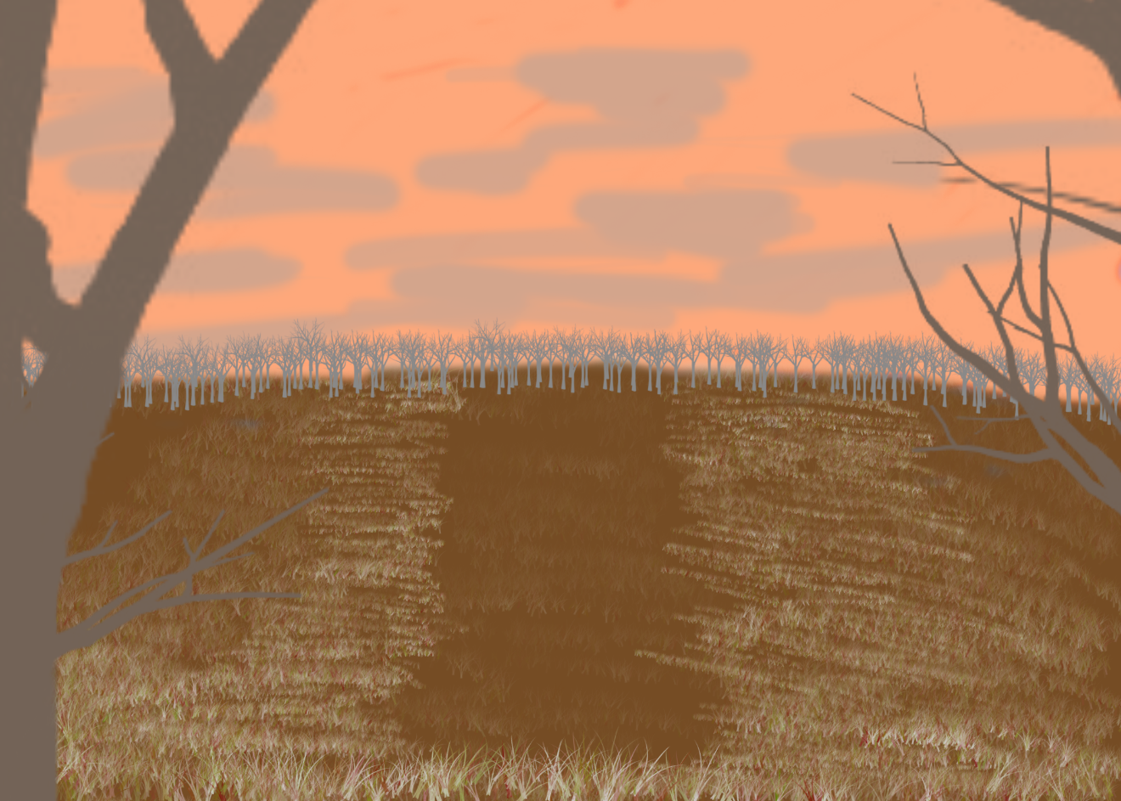

CHARACTER

The appearance of my game’s characters is not a huge focus. When it comes to the motion of the character, however, there will be running, grabbing objects, holding objects, and more. 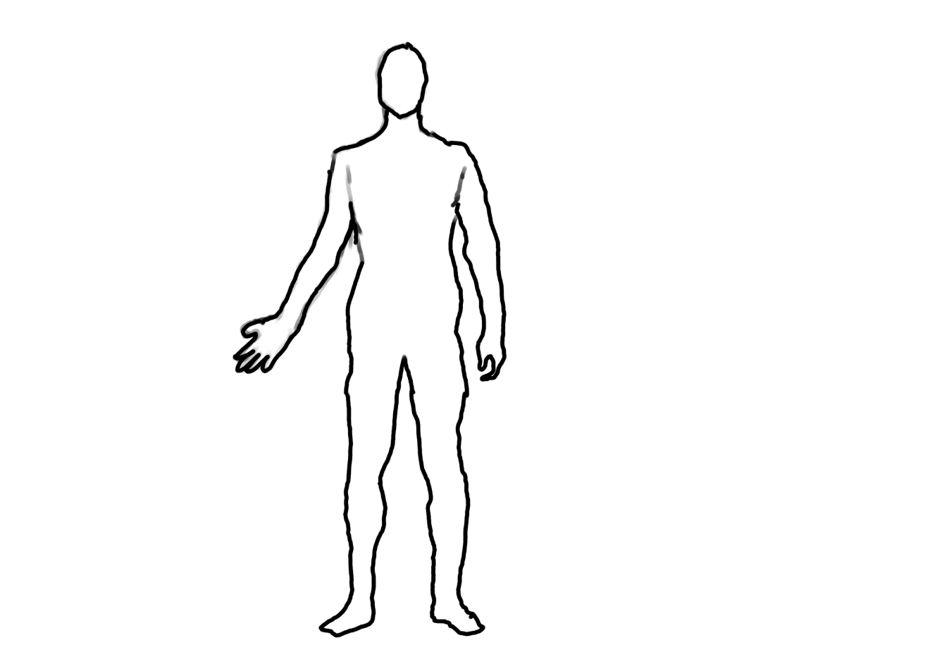

OTHER ITEMS

This would be the basic design of the gun that I will be using.

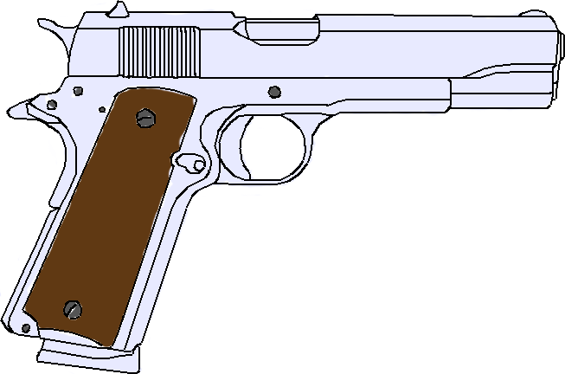

INTERFACE

The information about the player’s health, ammo count will be displayed on the weapon that the character is currently holding to limit the amount of things on the screen.

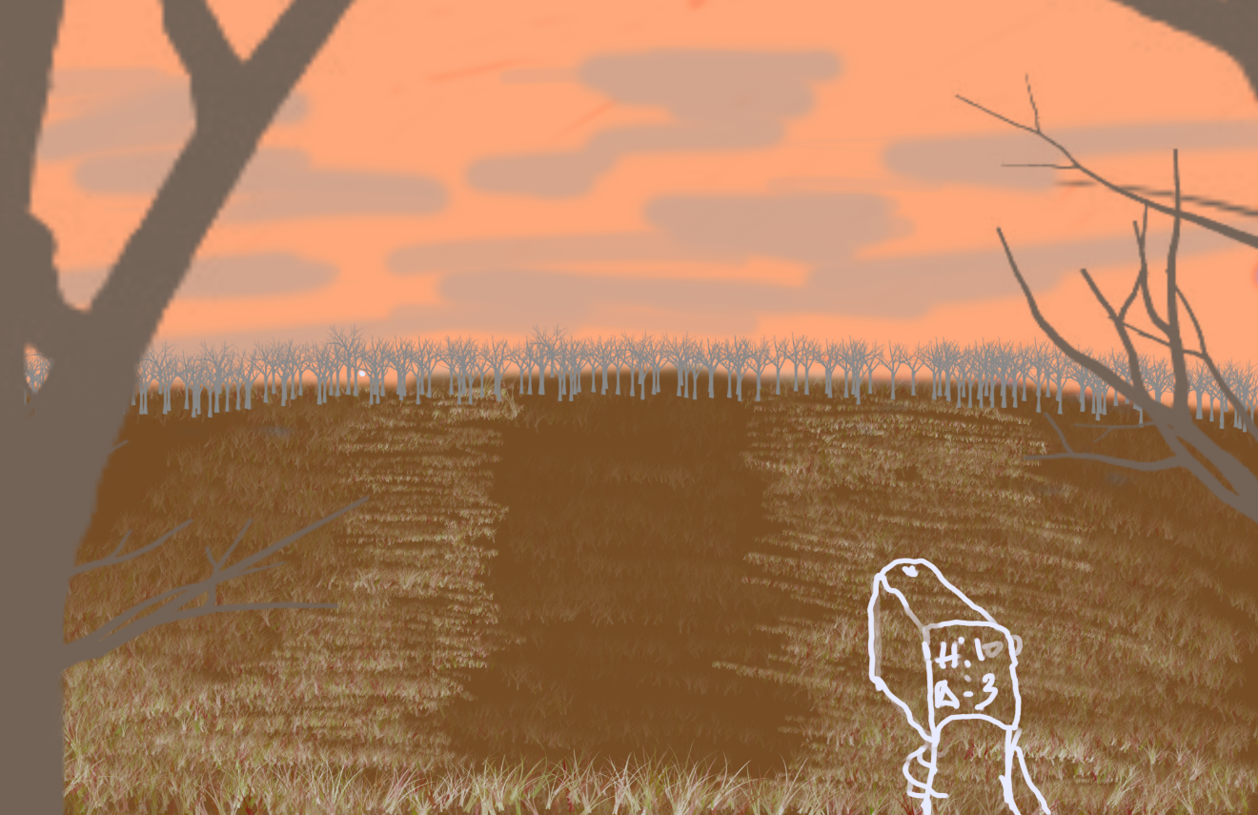

List of Art Assets

* 1 character model with different skins
* Environmental pieces – buildings, the forest, the skybox, water
* Weapons – guns
* Ammo
* 1 Mutated beasts

MUSIC

The music in the game will be dark and uneasy sounding. I want it to play at least for the start screen since hearing others and different in game things are more important. I also want very little music during the actual game because I want the feel of being isolated to be a large part of the gameplay.

WORLD SOUNDS

The world sounds are going to be mostly beasts in the distance and noise from environmental things like rivers or wind. Since the location is in a fallout zone, there isn’t going to be a lot of live animals to make noise. I want the game to have an uneasy feel and a sense of being out there alone.

GAMPLAY SOUNDS

The player will have multiple in game sounds. The player will make footsteps when walking and running, but none if crouched. There will be a death sound for being both shot and stabbed. The Beasts will also have their own sounds as well.

LIST OF SOUND ASSETS

* Title screen and menu music
* Beast Noises
* Walking Noises
* Running Noises
* Door noises
* Gun shots
* Stabbing noises
* Various Footstep Noises
* Water Running
* Wind

DEVELOPMENT TOOLS

Based off the online manual for Unity, I would need to use quite a few topics from it. The very first thing I would need is physics because any game would need to have some sort of physics especially with the implementation of jumping and potentially bullet drop. The next thing would be the multiplayer networking so that more than one person can play the game at a single time and everything stays sync’d up correctly from player to player. The next one would be the implementation of VR as it is a huge part of my game and the design of it will be based around VR. Another huge part will be navigation and path finding especially for my NPC beasts that work off of AI. If that aspect of the game is not good, it could ruin the playability and the quality greatly. Graphics are going to play a huge role in my game as well. I intend to have it look as good as it can be and that would require some custom shaders, skyboxes, and general environmental graphics. This will take a large part of time to make sure the graphics give the player the correct feel of the game I am going for.

FUTURE DIRECTION

From the conclusion of GIMM 350, I intend to put a lot of work into the assets and getting the multiplayer to work. As of right now, the very basic core mechanics of movement and the ability to shoot are done. Another focus will be integrating LEAP motion into the game, but I don’t plan on that being too difficult to add.

DEVELOPMENT SCHEDULE

Spring 2017:

GDD will be done and game sounds will be started.

Summer 2017:

Game sounds will be done and environmental design will begin.

Fall 2017:

GIMM 330 and GIMM 350.

Basic hitboxes and shooting works as well as basic player movement.

Character and weapon designs will begin.

VR will start to work and path finding for the beasts will begin.

Spring 2018:

GIMM 310.

Basic networking server up and rough bones of the game will be done.

The environment should be 90% done.

Summer 2018:

Characters, beasts, and weapons will be finished up.

Fall 2018:

GIMM 400.

Cleaning up loose ends and tweaking final gameplay.